**Release Date: 26 Mar 2021**

**Schedule K1 POST**

**End** **Point**: **[POST]/v2/partnership-schedule-k1s**

**Change:**

Add 4 fields in Stateformline

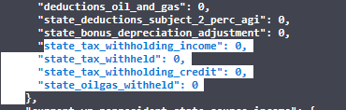

**Bug Fix: Date_of_disposition field is made Nullable to match the database.** Even when Date of disposition has some value in UI and not included in Payload now the request will be successful and the field value will remain as it is.

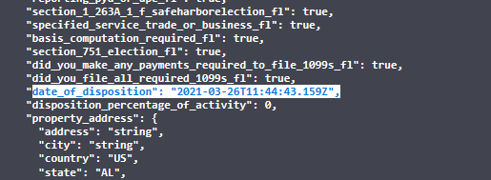

**Sales OData**

**End Point:** **/v1/odata/sales/tax-years/{year}/pans/{pan}/sales**

**Change 1:** Updated next link to match with request URL.

**Change 2:** Add 1099 NEC Flag - Account Model



**Transaction OData**

**End Point:**

**/v1/odata/transactions/tax-years/{year}/pans/{pan}/transactions**

**Change 1:** Updated next link to match with request URL.

**Change 2:** Add 1099 NEC Flag - Account Model



**Account Tracking OData**

**End Point:**

**/v1/odata/tracking/tax-years/{year}/pans/{pan}/accounts/statuses**

**/v1/odata/tracking/tax-years/{year}/pans/{pan}/accounts/milestones**

**/v1/odata/tracking/tax-years/{year}/pans/{pan}/recipients/statuses**

**/v1/odata/tracking/tax-years/{year}/pans/{pan}/recipients/milestones**

**/v1/odata/tracking/tax-years/{year}/pans/{pan}/states/statuses**

**/v1/odata/tracking/tax-years/{year}/pans/{pan}/states/milestones**

**Change:** Updated next link to match with request URL.